Alodokter Mobile Test

Noted :

1. First, Thank you for your participation, time and effort. We really appreciate that
2. Please use java/kotlin for android or swift for iOS based on position you apply
3. Use github for distribute your project with us.
4. We will look the structure of the project.
5. There should open login screen when user open apps
   1. User cannot move to home screen if email and password is empty
   2. Save user account to local storage, so if user open the apps again it will jump to home screen

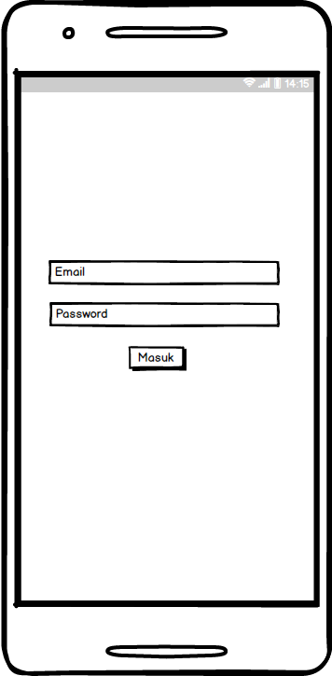

1. After login, user will direct to home screen. Home screen have 2 tab : Home and profile
   1. Use your own image but please use polite and considerate image

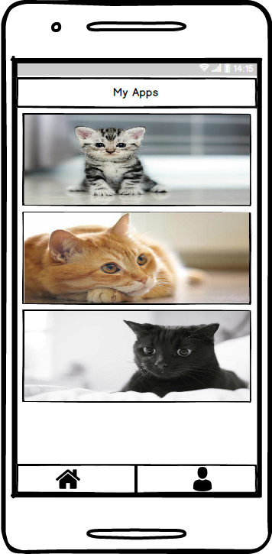

1. If user choose one of the item in list it will direct to detail page. In Detail page there are slide with minimal 3 image

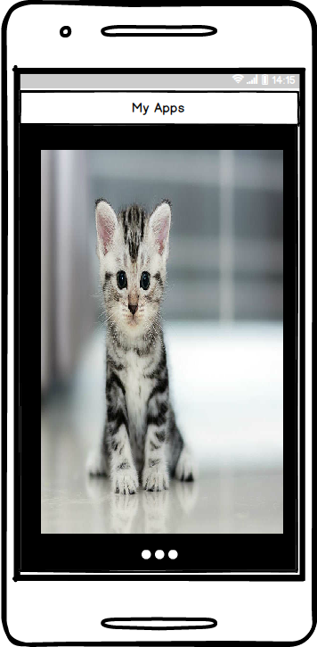

1. In Tab Profile. It will show user profile

